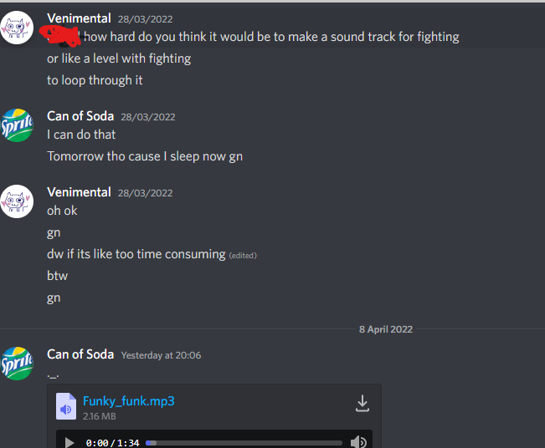

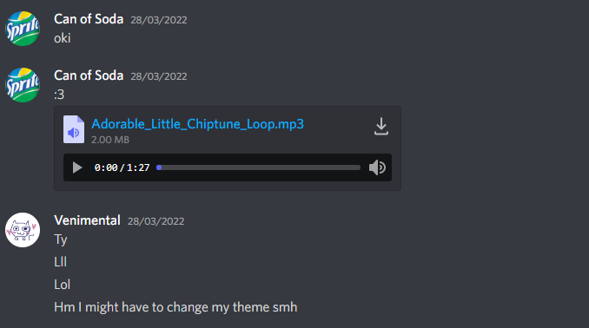

My friend made my backing track for me

Links:

Game art 2d and craftpix both have licenses for me to use without limits both commercially and uncommercially so I am not breaking copyright by using resources that are from these websites

<https://craftpix.net/file-licenses/>

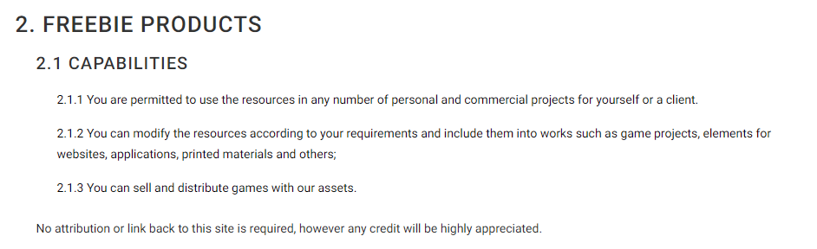

<https://www.gameart2d.com/license.html>

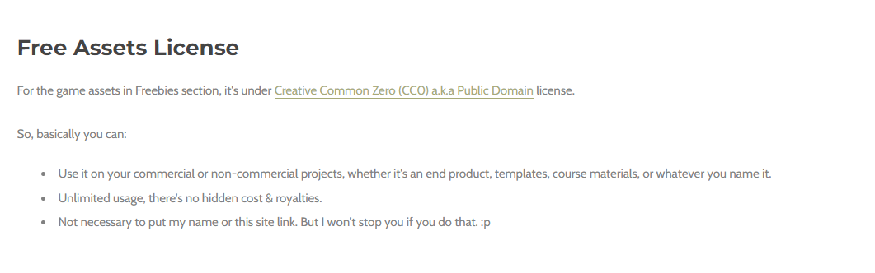

<https://craftpix.net/freebies/free-dungeon-platformer-pixel-art-tileset/>

<https://www.kenney.nl/assets/platformer-art-deluxe> (free to use)

<https://www.gameart2d.com/ninja-adventure---free-sprites.html>

<https://www.gameart2d.com/ninja-girl---free-sprites.html> (CC0 license so I can use it without limitations)

<https://iconduck.com/emojis/16514/dash-symbol>

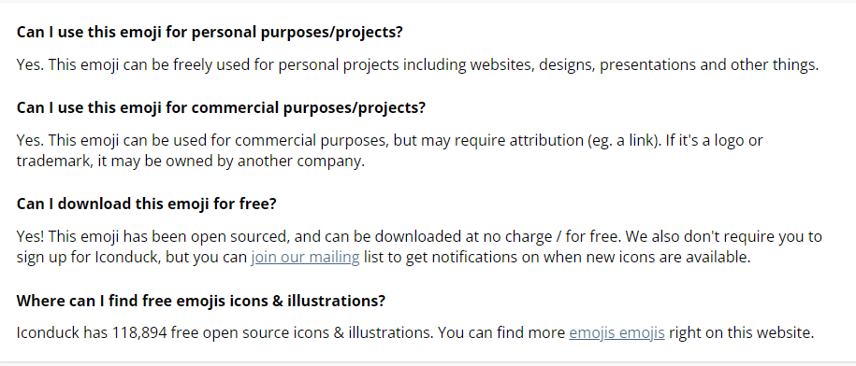

**This dash icon is able to be used for free for both personal and commercial purposes so I am not breaking copyright for using it. I have also included a link for attribution as required**

<https://craftpix.net/freebies/free-fallen-angel-chibi-2d-game-sprites/>

<https://craftpix.net/freebies/free-golems-chibi-2d-game-sprites/>

<https://craftpix.net/freebies/free-minotaur-tiny-style-2d-sprites/>

<https://craftpix.net/freebies/free-golem-tiny-style-2d-character-sprites/>

<https://craftpix.net/freebies/free-wraith-tiny-style-2d-sprites/>